Quick Start Guide to Documentation
Learning to Document, Documenting to Learn

When and what do I document?

- When I notice students learning through play in a way that surprise, inspires, or excites me
- When my absence from the learning experience will not adversely affect the learning
- When I notice a pattern in behavior, confusion, or ideas that I want others to notice
- When I am, or an individual or group of students is, struggling or has a question and wants to understand someone or something more completely
- When I want to tell or help a child to tell a story of learning
- When an “Aha!” moment seems to be happening for an individual or group
- When we are working on a specific skill, strategy, or routine and need evidence to assess progress
- When I know someone will ask, “What are they learning from doing this?”
- When I anticipate changes in thinking, understanding, or behaving over time
- When I find myself feeling like things are or are not “going well” and I need evidence to support my perception
- When I sense a quality of engagement or disengagement that is striking
- When groups (small or large, successful or unsuccessful) are working together without teacher facilitation
- When I notice purposeful and connected discourse of almost any kind
- When language or memory is a weakness for one or more students
- When I hear voices that are seldom heard or notice struggling students feeling successful
- When I want to make individual thinking visible and accessible to the group—e.g., to share an idea that will move individual or group thinking forward, demonstrate multiple perspectives (or disagreement) about a single topic, or challenge misconceptions

How do I document?

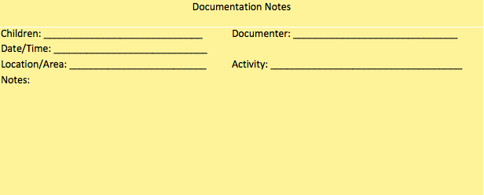
- Keep baskets with “documentation note” papers and pens handy around the classroom (see example). When you see something interesting, jot it down on a note and put it back in the basket. When you have prep time, gather the notes and look through them, adding to students’ portfolios or saving to share with students, parents, or colleagues.
sample documentation note form example
- Take a photograph and write down what students are saying/doing in that moment.
- Invite one or two students to hold a camera or video camera and capture a learning experience.
- Record a conversation. You can use your phone or audio recorder OR write down what students are saying – either on a chart paper so they can see you writing the ideas, in your notebook, or on post-its.
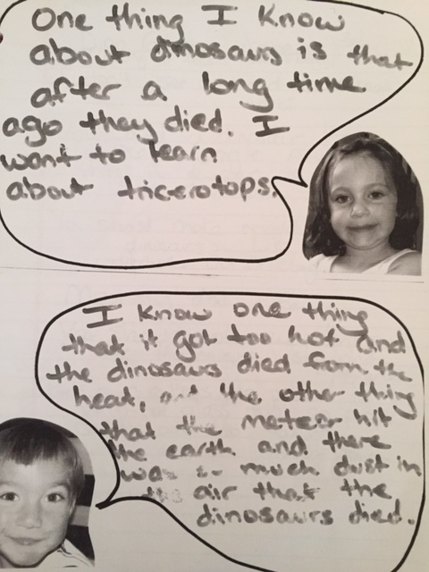
- Take a short video (1-3 minutes) of a moment during a learning experience. OR, set up a video camera on a tripod to record an experience you’re especially excited about, and later cut out a short clip of video to share. (If possible, jot down the time(s) you’d like to return to.)
- Exit ticket/tweet: Ask students to jot down one insight and one puzzle (or something they learned from another student) before they leave class.
- When posting student work, add a few sentences about what you learned about your students’ learning.
- Use speech bubbles (see example to the right). Copy or laminate speech bubble pages for each of your students with a photograph of the student and an empty bubble. Write interesting or provocative comments into the bubbles and post.
- Sometimes after the experience (notes can be jotted down from memory or photos re-enacted) to travel back in time and facilitate revisiting

What do I do next?

- Reflect on your own or with colleagues
  - Post something to your study group’s Padlet and ask for See-Think-Wonder comments.
  - Start a routine of sharing a short video clip or other type of student work with your colleagues at the start of your planning meetings.
  - Post a piece of documentation in the staff room with a note asking colleagues to respond to a particular question on a post-it.

- Share documentation back with learners
  - Share back a provocative or insightful comment, question, or exchange from one or more learners.
  - Post photographs of learning moments or artifacts on a wall with a caption or question. Revisit with students and write down what they say.
  - Share a few moments of video, a couple of quotes, or a photo from a previous lesson as a reminder of important learning moments before you begin the current lesson.

- Share more widely
  - Ask your students which part of their learning they most want to share with the school community and in what format.
  - Make one aspect of the learning process visible when putting on performances, exhibitions
  - Post documentation outside of the classroom for the school community to see.

Based primarily on Van Vleck, 2011

